## horizontal line



How to guide: Salesforce Flow Builder

11.04.2022

Chelsea Douglas

# 

# 1. Object Creation:

Create custom object named:

a. Course

b. Subjects

c. Course Leads

d. Technology

## Create an Object

Step 1: Click on Setup

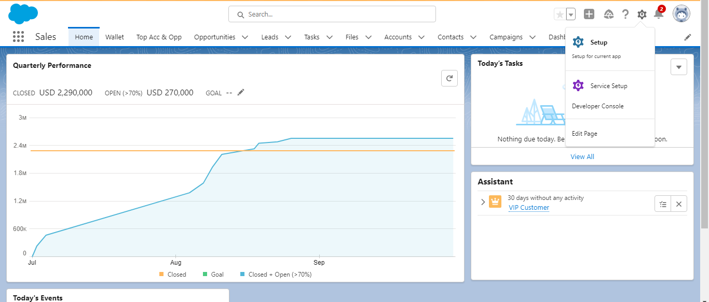

Step 2: Click on Object Manager

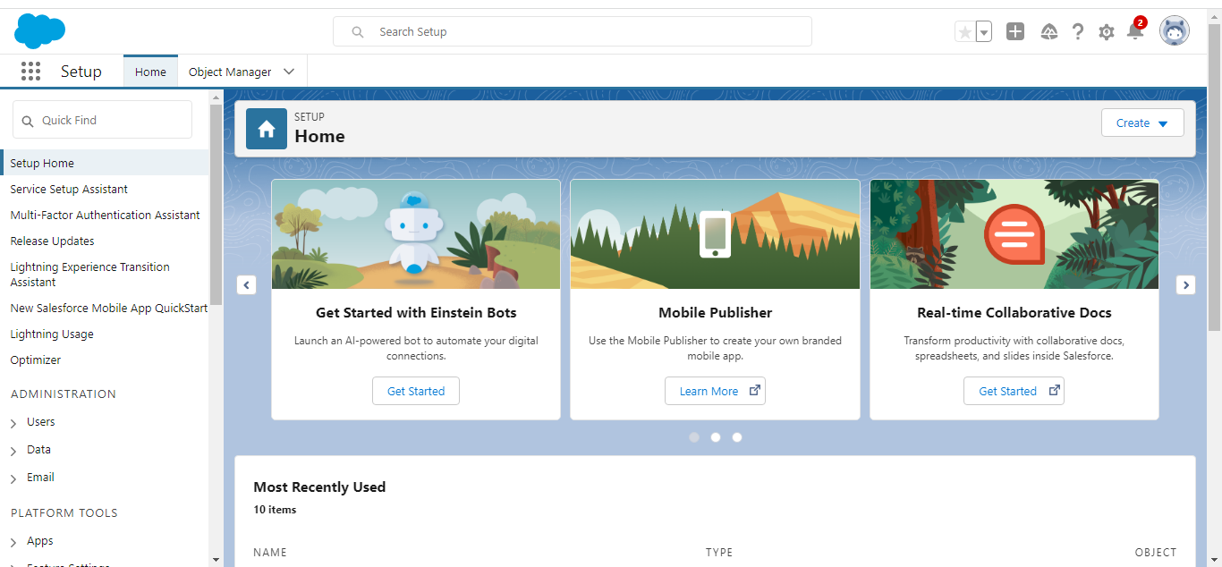

Step 3: In the top right-hand corner click on Create and then click Create Custom Object

Step 4: Fill in the Label, which is what you want that custom object to be, the Plural Label will just be the plural name for what you put in the Label section. Object Name should have automatically populated once you filled in your Label as well as Record Name. Choose your Data Type as well in this step

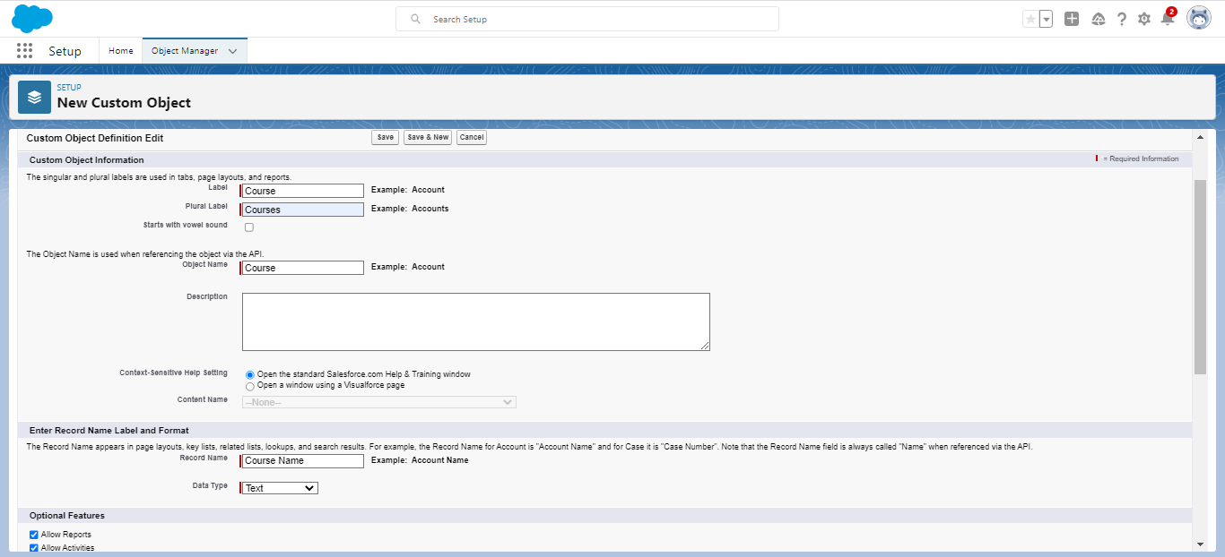

Step 5: Click Save

After saving you will be brought to the detail page for the Custom Object you just created

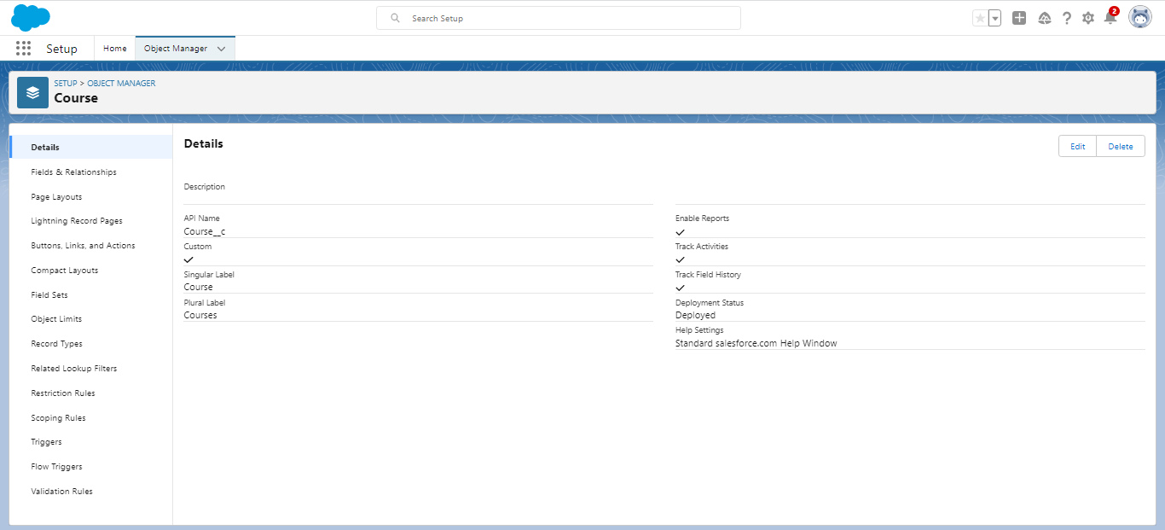

Step 6: Go back through and repeat steps 1-5 to create the objects named Subjects, Course Leads, and Technology.

# 2. Create Fields for the related objects:

1. Course
   1. Course Name
   2. No. of Modules
   3. Course Duration
   4. Rating
   5. Active
   6. Instructor Name
   7. Type of Course
   8. Priority
   9. Start Date
   10. End Date
2. Subject
   1. Subject Name
   2. No. of Modules
   3. Instructor Name
   4. Rating
   5. Priority
   6. Category
   7. Level
3. Course Leads
   1. First Name
   2. Last Name
   3. Phone
   4. Email
   5. Source
   6. Category
   7. Rating
   8. Currency
   9. Course Lead Amount
4. Technology
   1. Name
   2. Type
   3. Category
   4. Rating
   5. Active
5. Instructor Name
6. Mobile
   1. ii. Email
   2. iii. Qualification
   3. iv. Availability

## Create a Field

Step 1: In the Setup Menu go to Object Manager. In Object Manager you will search for the first custom object listed which is Course, select Course.

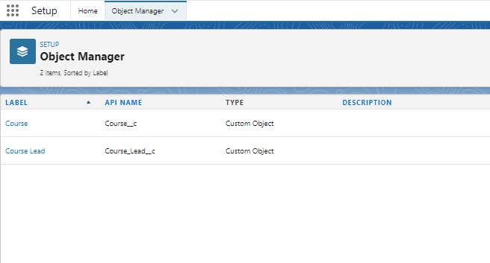

Step 2: Next, select Fields & Relationships using the side panel then select New.

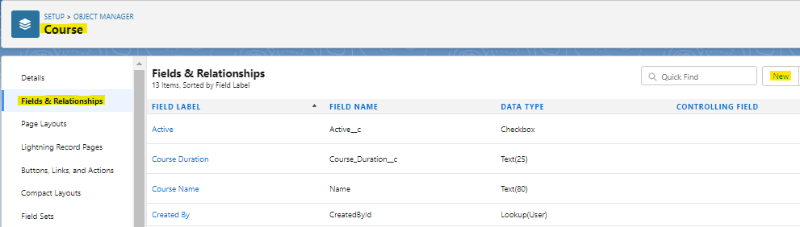

Step 3: Select the field type then click next

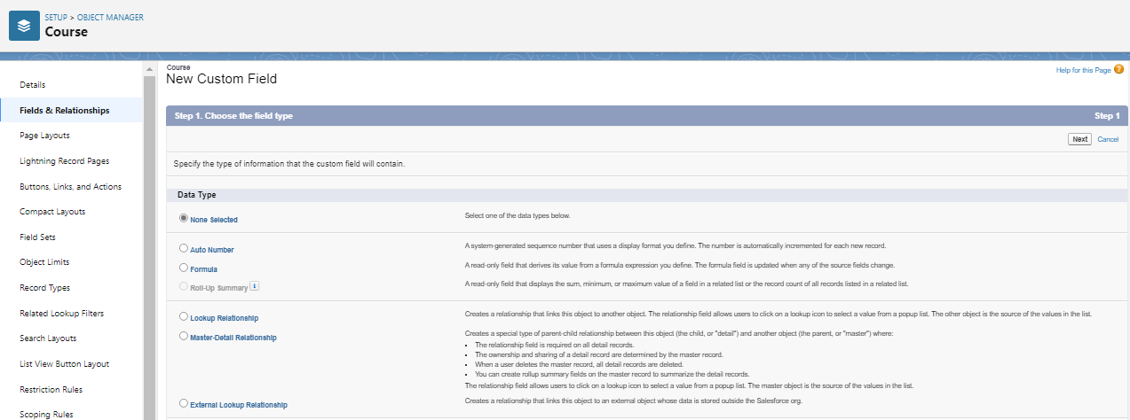

Step 4: Enter the details regarding the field label and length. Field Name will auto-populate once you enter the field label, then click next.

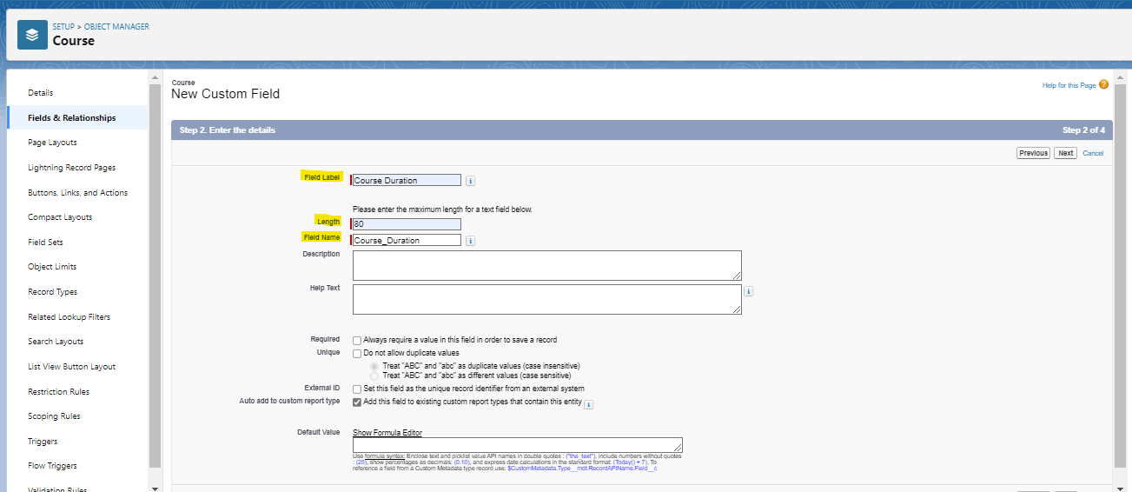

Step 5: Update or use the default field-level securities, then click next.

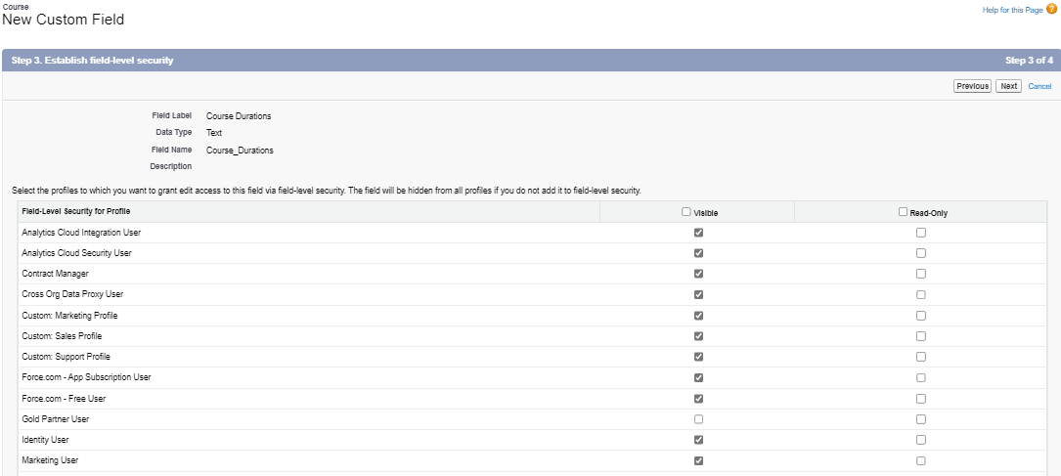

Step 6: Lastly, you will add the field to the page layouts by selecting save. Repeat these steps for the remaining fields using the specified objects.

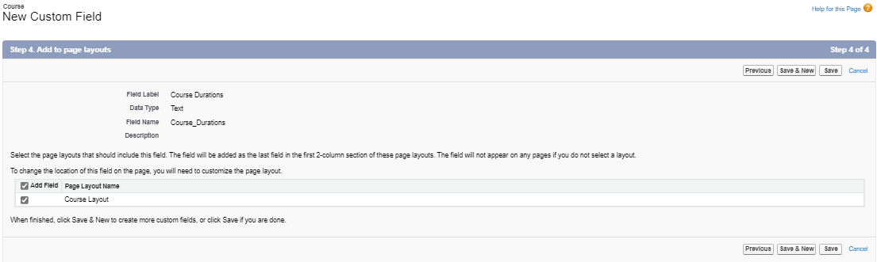

# 3. Add Validation Rules for verifying data:

Add a validation rule for every field to verify that the fields are not empty for the objects:

* Course
* Subjects
* Course Leads
* Technology

## Create a Validation Rule

Step 1: In the Setup Menu go to Object Manager. In Object Manager search for the first custom object, Course. Click on Course.

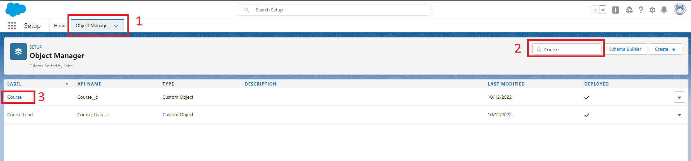

Step 2: Click on Validation rules, then click on New

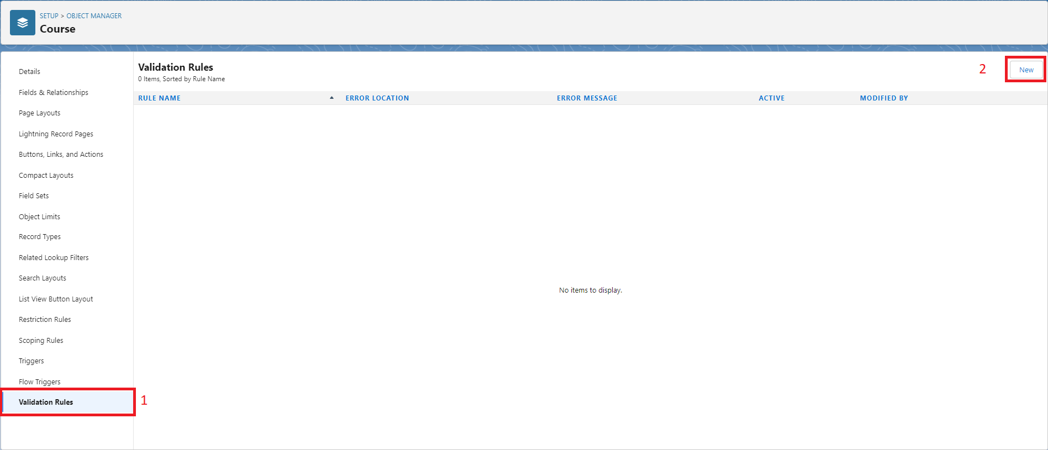

Step 3: Fill in the Rule Name and provide a description. We can now begin to build the Error Condition Formula.

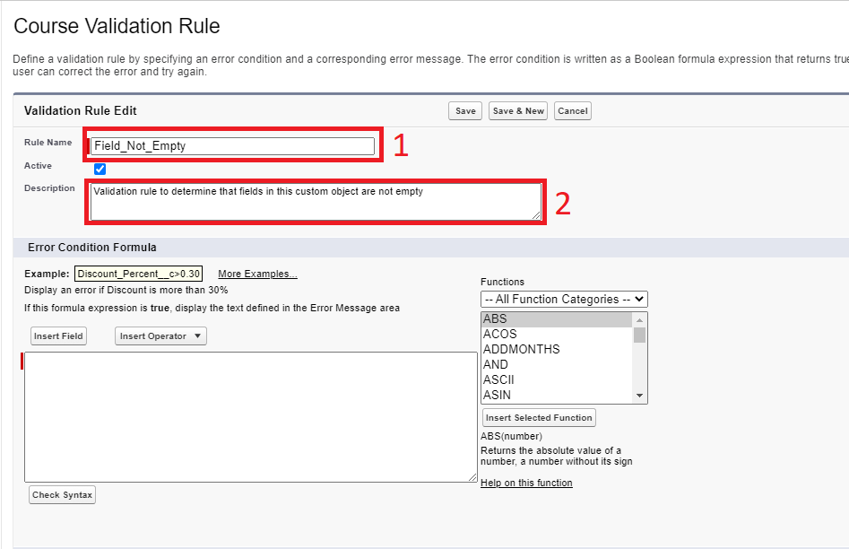

Step 4: Begin by adding a Function. Go to the Functions picklist and select the OR function. Click on Insert Selected Function. We can continue to add functions as needed.

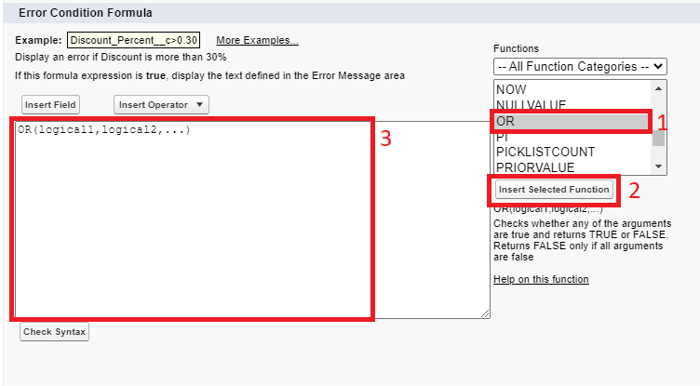

Step 5: Fields can be inserted by clicking on Insert Field. This screen will pop up. Select the field you want to include then click on Insert.

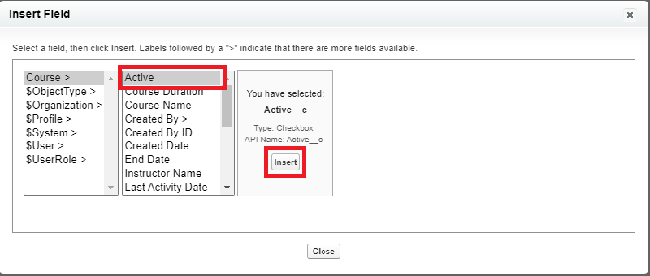

Step 6: Build the following formula for the fields in the Course object.

OR(

ISBLANK( Name ),

ISBLANK( No_of_Modules__c ),

ISBLANK( Course_Duration__c),

ISPICKVAL( Rating__c ," "),

ISBLANK( Instructor_Name__c ),

ISBLANK( Type_of_Course__c ),

ISPICKVAL( Priority__c ," "),

ISBLANK( TEXT(Start_Date__c)),

ISBLANK( TEXT(End_Date__c)),

Active__c = FALSE

)

The ISBLANK function can be used for text , number, and currency fields.

The ISPICKVAL function is used for Picklist fields.

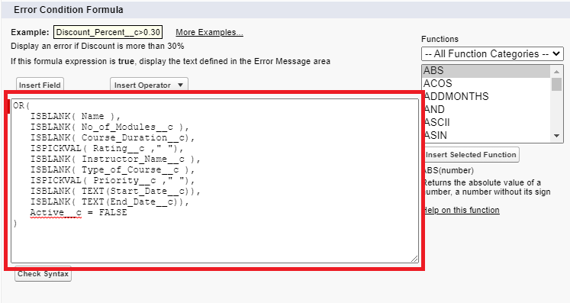

Step 7: Enter and Error Message. Click on Save.

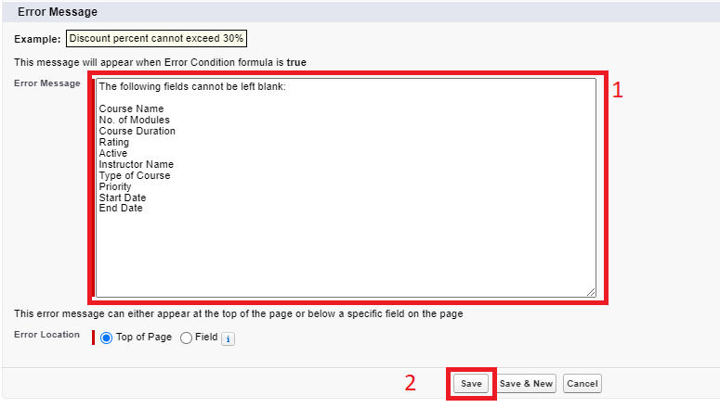

Step 8: Time to test the Validation Rule. Go to the Sales app, then click Courses.

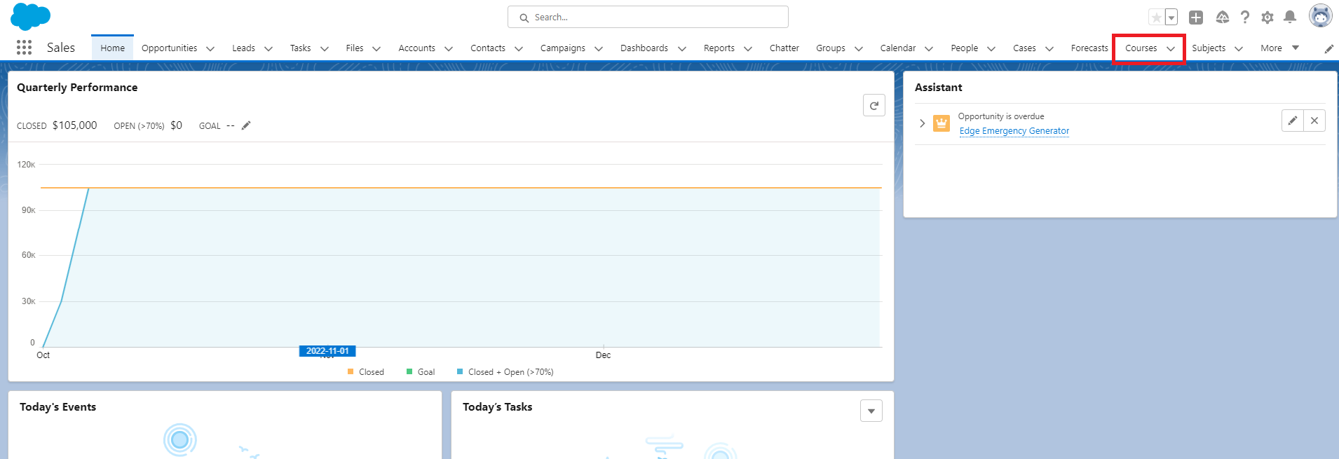

Step 9: Click New.

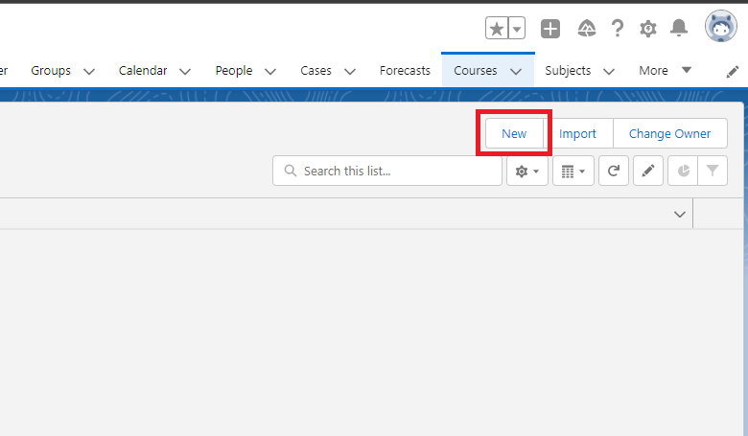

Step 10: Fill in all the fields for the Course object. Make sure to leave one blank. Click on Save. If the Validation Rule is working correctly then the Error Message will pop up.

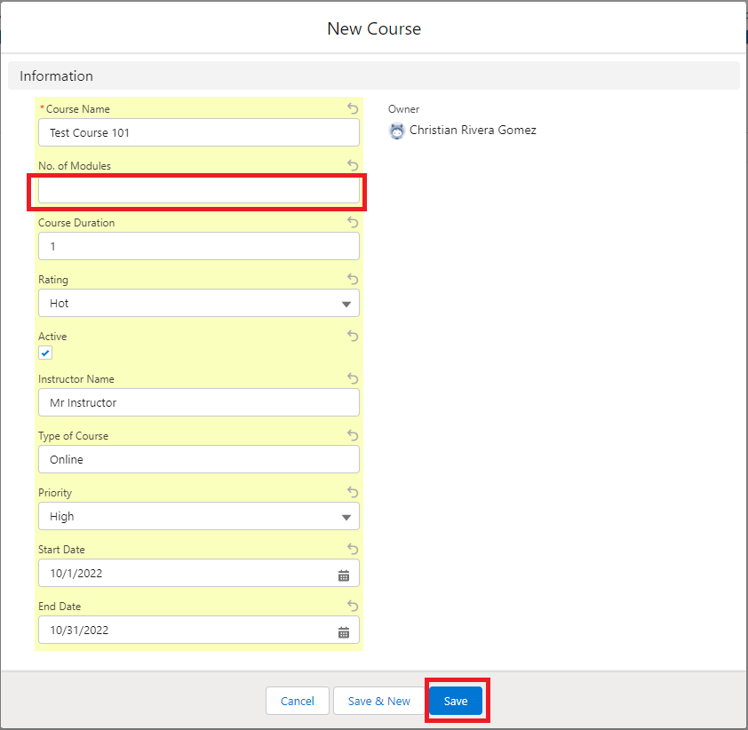

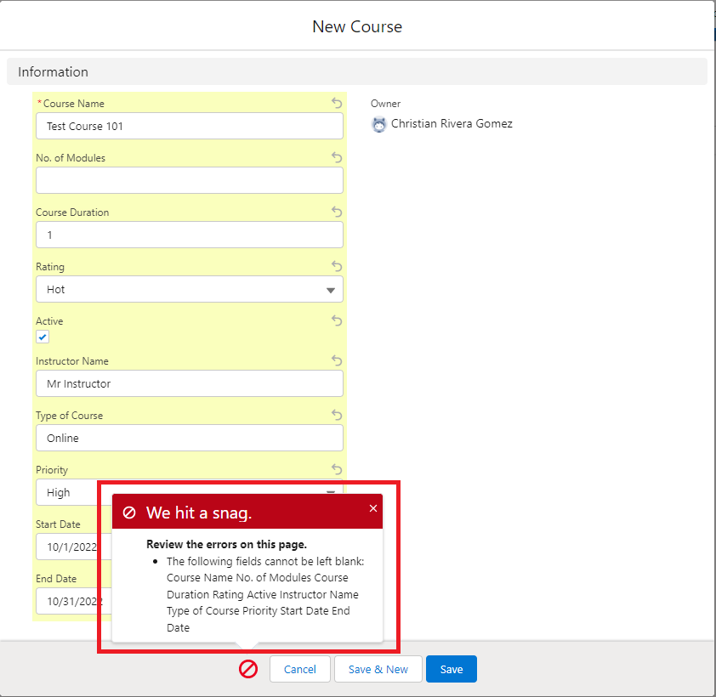

Step 11: Continue to test the Validation Rule by leaving a different field blank each time you try to save until you have ensured that a blank in all the fields results in the Error Message appearing.

Step 12: Repeat Steps 1 through 11 for the Subject, Course Lead, and Technology objects. For Step 6 use the formulas provided below for the respective custom object.

SUBJECT OBJECT

OR(

ISBLANK( Name ),

ISBLANK( No_of_Modules__c ),

ISBLANK( Instructor_Name__c),

ISPICKVAL( Rating__c , " "),

ISPICKVAL( Priority__c, " "),

ISBLANK( Category__c ),

ISPICKVAL( Level__c , " ")

)

COURSE LEAD

OR(

ISBLANK( First_Name__c ),

ISBLANK( Last_Name__c ),

ISBLANK( Phone__c ),

ISBLANK( Email__c ),

ISBLANK( Source__c ),

ISBLANK( Category__c ),

ISPICKVAL( Rating__c , " "),

ISBLANK( TEXT( Currency__c ) ),

ISBLANK( Course_Lead_Amount__c )

)

TECHNOLOGY

OR(

ISBLANK( Name ),

ISBLANK( Type__c ),

ISBLANK( Category__c ),

ISPICKVAL( Rating__c , " "),

Active__c = FALSE

)

# 4. Set Workflow rules for all the custom objects created.

The workflow rules should be created in such a way that it should update the data after the following criteria is met:

* + - If the priority of course is high, then update the course name to 'High Priority'+ Course Name.
    - If the course lead amount is greater than USD $1000 then, give update the name field to 'Top Priority Customer'+ Name

## Set workflow rules for Course Name

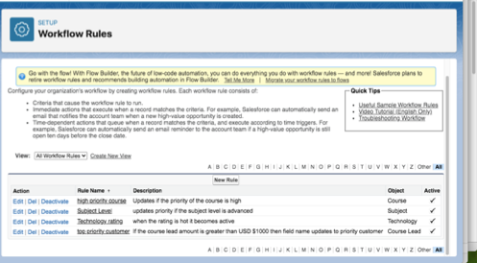

Step 1: Under Setup, search workflow rules. Select the Object (Course) and enter the rule name (high priority course).

Step 2: For evaluation criteria click “created, and any time it’s edited to subsequently meet criteria.”

Step 3: For Rule Criteria click “criteria are met”

Step 4: For the field choose “course: priority” for the operator “equals” for the value “high” and save.

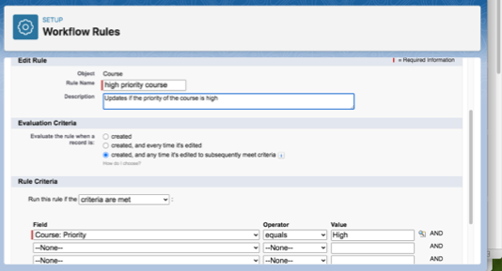

Step 5: Under Workflow Actions Click Add Workflow Option.

Step 6: Under specify new field value enter the formula “High Priority” + Name. Save. Activate.

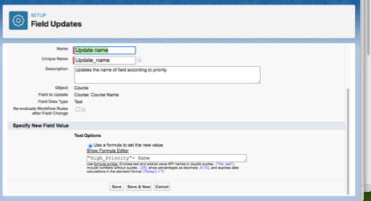

Step 7: Verify Workflow by updating a course to “high priority”

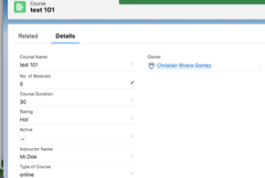

Step 8: When the priority is changed to high, the course name is updated to reflect that automatically.

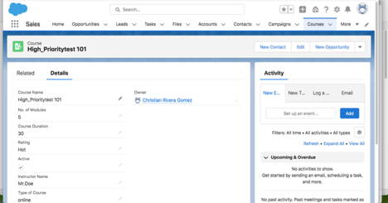

## Set workflow rules for Course Leads

If the course lead amount is greater than USD $1000 then, give update the name

field to ‘Top Priority Customer’+ Name

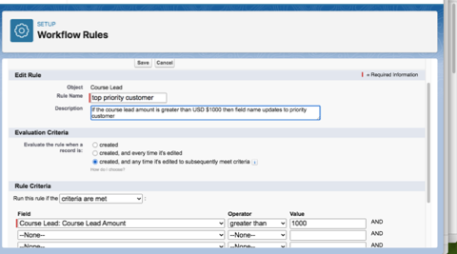

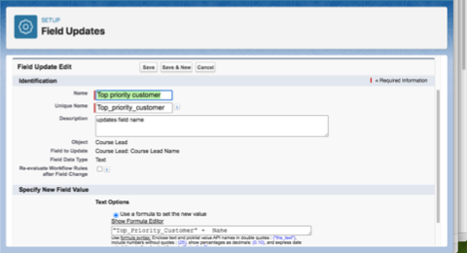

Once This Workflow is activated, if the course lead amount is greater than USD $1000, then the name is updated to reflect a top priority customer.

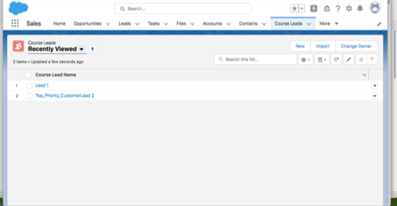

# 5. Create a flow using the below scenario for creating a Case.

First, the user should enter the following fields in the case:

* Name
* Phone
* Email
* Course Enrolled
* Subject
* Instructor Name
* Query Description

After the case is created, assign the case to the course instructor.

If the instructor is unavailable, assign it to a specific executive of the company. Further, when the query is resolved, update the Case as ‘Resolved’.

## Creating the fields for the case.

Step 1: Click "Home", next click the "Quick Find" field. then Type "flow" and click "Flows", next click “New Flow”.

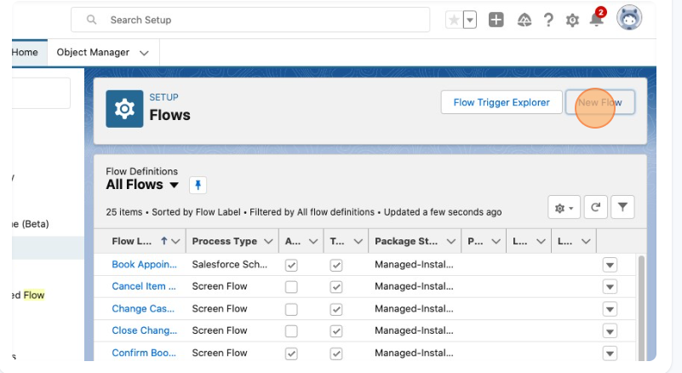

Step 2: Click "Screen", next Click the "Search" field. Type “name” and click “Name”, And repeat this process with Phone, and Email.

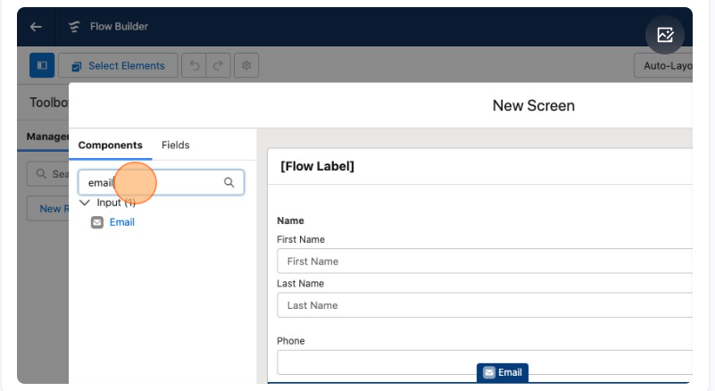

Step 3: For the remaining fields Course Enrolled; Subject, Instructor Name, Query Description you’ll have to type in “text” and select “text” then type the name of the field you are creating into the “Label”.

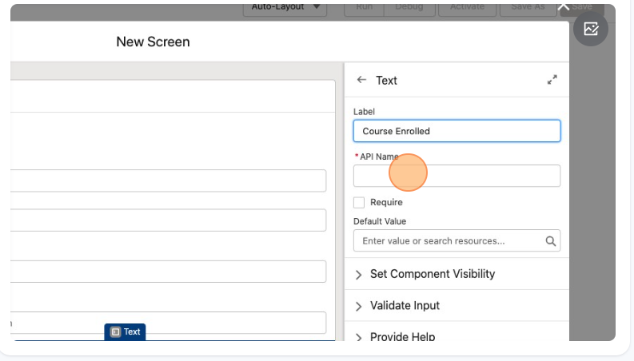

Step 4: For the “API Name” you’re going to type in the matching field name then click Done.

Step 5: Next click the + button underneath the screen tab and scroll down and click on assignment. New assignment will appear, in the “Label” field type in “Course Instructor”. Click the "Variable" dropdown field, click "Instructor Name" and Click "Last Name".

Step 6: On the “Operator” dropdown field click “Equals”, Then click done.

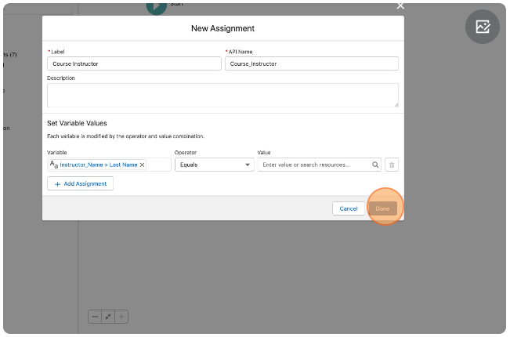

Step 7: Under the “Course Instructor Assignment” click the + button and click the Update Records.

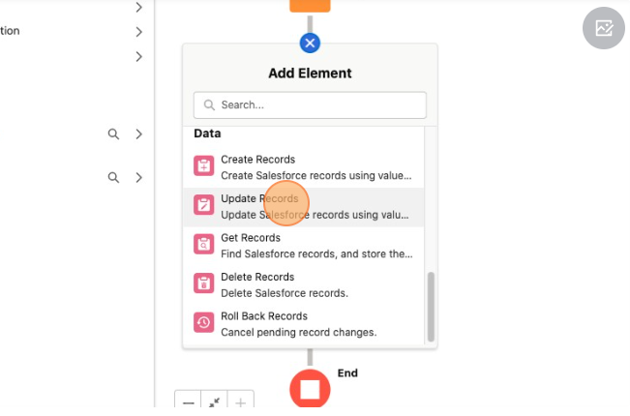

Step 8: Click the "*Label" field Type "Resolved".

Step 9: On the “How to find Records to Update and set their values” select the “specify conditions to identify records and set fields individually”.

Step 10: For the “Object” field select “Instructor Name” next click on the “Field” tab and select “Name”, click “Operator” select “Equals”, and then click on the “Value” and select “Course Enrolled”.

Step 11: Lastly under the “Set Field values for the Instructor Name records” for the “Field” select “Name” and click “Done”